Screenshot of Different Results

Batch Size of 100 and Length of sequence 50 , Epoch size of 3 (including clean text function)

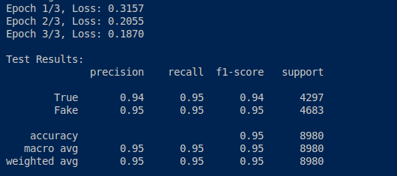

Batch Size of 15 and Length of sequence 20, Epoch size of 3 (including clean text function)

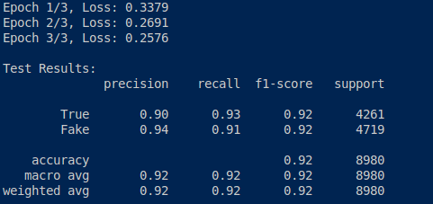

Batch Size of 15, Length of sequence 20, Epoch size 10, and addition of the clean text function (Location and New Source located on TrueNews.csv text)

